1.
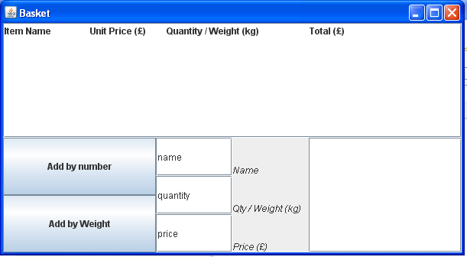

Initial state with no user interaction.

2.
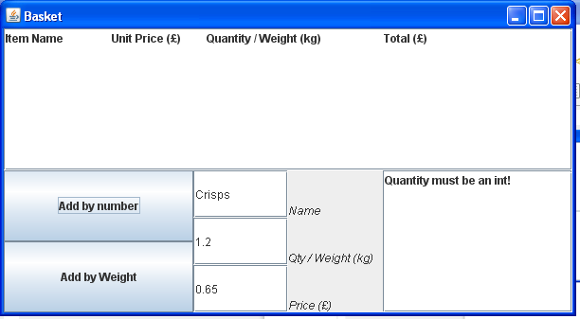

Erroneous quantity input.

3.
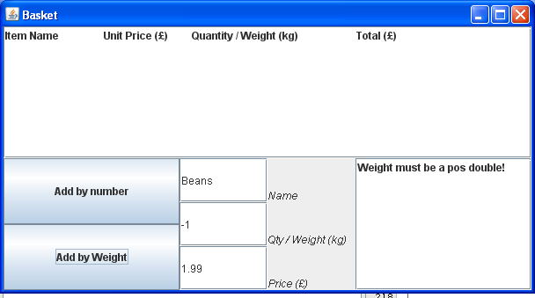

Erroneous weight input.

4.

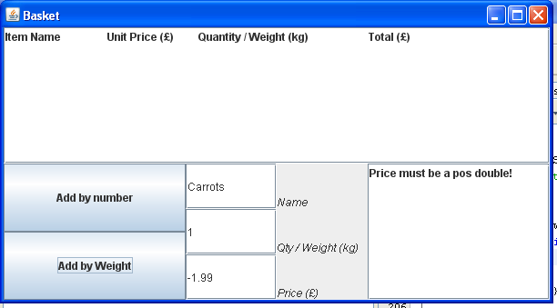
Erroneous price input

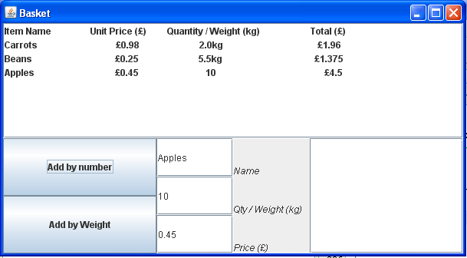
Three successfully added items.

5.

6.

private JFrame mainFrame = new JFrame ("Basket");

//Panel for the buttons
private JPanel buttonPanel = new JPanel();

//Panel for the text inputs
private JPanel inputPanel = new JPanel();

//Panel to contain all of the lower part of the GUI
private JPanel lowerPanel = new JPanel();

//Scroll pane used for the shopping list
private DefaultListModel shoppingListModel = new DefaultListModel();
private JList shoppingList = new JList(shoppingListModel);
private JScrollPane listScrollPane = new JScrollPane(shoppingList);

//The two buttons for interaction
private JButton addNumber = new JButton("Add by number");
private JButton addWeight = new JButton("Add by Weight");

//The input text fields
private JTextField itemName = new JTextField("name");
private JLabel itemNameLabel = new JLabel("Name");
private JTextField quantity = new JTextField("quantity");
private JLabel quantityLabel = new JLabel("Qty / Weight (kg)");
private JTextField price = new JTextField("price");
private JLabel priceLabel = new JLabel("Price (£)");
private Font labelFont=new Font(itemNameLabel.getFont().getName(),Font.ITALIC,
itemNameLabel.getFont().getSize());

//JList to display the errors
private DefaultListModel errorListModel = new DefaultListModel();
private JList errorList = new JList(errorListModel);
private JScrollPane errorScrollPane = new JScrollPane(errorList);

private Scanner inputScanner;

private ArrayList<PurchaseByNumber> purchasesByNumber = new ArrayList<PurchaseByNumber>();
private ArrayList<PurchaseByWeight> purchasesByWeight = new ArrayList<PurchaseByWeight>();
private ArrayList<String> errorArrayList = new ArrayList<String>();

StringBuilder builder = new StringBuilder();
Formatter formatter = new Formatter(builder, Locale.US);

public ShoppingApp(){

addNumber.addActionListener(this);
addWeight.addActionListener(this);

//Fix dimensions for gui
listScrollPane.setPreferredSize(new Dimension(600, 150));
buttonPanel.setPreferredSize(new Dimension(200,150));
inputPanel.setPreferredSize(new Dimension(200,150));
errorScrollPane.setPreferredSize(new Dimension(200,150));

//Setup the button panel
buttonPanel.setLayout(new GridLayout(2,2));
buttonPanel.add(addNumber);
buttonPanel.add(addWeight);

//Setup the input panel
inputPanel.setLayout(new GridLayout(3,3));
inputPanel.add(itemName);
inputPanel.add(itemNameLabel);
inputPanel.add(quantity);
inputPanel.add(quantityLabel);
inputPanel.add(price);
inputPanel.add(priceLabel);

//Set label parameters for input panel labels
itemNameLabel.setVerticalAlignment(SwingConstants.BOTTOM);
itemNameLabel.setFont(labelFont);
quantityLabel.setVerticalAlignment(SwingConstants.BOTTOM);
quantityLabel.setFont(labelFont);
priceLabel.setVerticalAlignment(SwingConstants.BOTTOM);
priceLabel.setFont(labelFont);

//Encompass all of the above in the lower panel
lowerPanel.setLayout(new BoxLayout(lowerPanel, BoxLayout.X_AXIS));
lowerPanel.add(buttonPanel);
lowerPanel.add(inputPanel);
lowerPanel.add(errorScrollPane);

//Setup the main container
Container contentPane = mainFrame.getContentPane();
contentPane.setLayout(new BoxLayout(contentPane, BoxLayout.Y_AXIS));
contentPane.add(listScrollPane);
contentPane.add(lowerPanel);

formatter.format("%1$1s %2$30s %3$30s %4$30s %n", "Item Name", "Unit Price (£)","Quantity / Weight (kg)","Total (£)");
shoppingListModel.addElement(formatter.toString());

mainFrame.setDefaultCloseOperation(JFrame.EXIT_ON_CLOSE);
mainFrame.pack();
mainFrame.setVisible(true);

}

7.

public interface PurchaseInterface {

public String getName();
public Double getUnitPrice();
public Double getPurchasePrice();
public String printPurchase();

}

public abstract class Purchase implements PurchaseInterface {
public String name;
public Double unitPrice;

public Purchase(String name, Double unitPrice){
this.name = name;
this.unitPrice = unitPrice;
}

@Override
public String getName(){
return name;
}

@Override
public Double getUnitPrice(){
return unitPrice;
}

//Implemented differently in each subclass
public abstract Double getPurchasePrice();
public abstract String printPurchase();

}

public class PurchaseByNumber extends Purchase {

private int quantity;

PurchaseByNumber(String name,Double unitPrice,int quantity){
super(name,unitPrice);
this.quantity = quantity;
}

@Override
public Double getPurchasePrice(){
assert quantity >= 0:"Quantity is invalid";
assert unitPrice >= 0: "Unit price is invalid";

return quantity*unitPrice;
}

//Additional method not in the super class
public int getQuantity(){
assert quantity >= 0:"Quantity is invalid";

return quantity;
}

@Override
public String printPurchase(){
assert quantity >= 0:"Quantity is invalid";
assert unitPrice >= 0: "Unit price is invalid";

StringBuilder builder = new StringBuilder();
Formatter formatter = new Formatter(builder, Locale.US);
formatter.format("%-30s %15s %30s %50s %n", name,"£"+ unitPrice,quantity,"£"+getPurchasePrice());

String output = builder.toString();
System.out.println(output);
return output;

}

}

public class PurchaseByWeight extends Purchase {

private Double weight;

PurchaseByWeight(String name, Double unitPrice, Double weight){
super(name,unitPrice);
this.weight = weight;
}

@Override
public Double getPurchasePrice(){
assert weight >= 0:"Weight is invalid";
assert unitPrice >= 0: "Unit price is invalid";

return weight*unitPrice;
}

//Additional method not in the super class
public Double getWeight(){
assert weight >= 0:"Weight is invalid";

return weight;
}

@Override
public String printPurchase(){
assert weight >= 0:"Weight is invalid";
assert unitPrice >= 0: "Unit price is invalid";

StringBuilder builder = new StringBuilder();
Formatter formatter = new Formatter(builder, Locale.US);
formatter.format("%-30s %15s %30s %45s %n", name, "£"+ unitPrice,weight+"kg","£"+getPurchasePrice());

String output = builder.toString();
System.out.println(output);
return output;

}

}

8.
Erroneous inputs were handled in two stages. The first stage was making sure that the input was in the correct format. This was checked by catching any exceptions. The second was checking that the numeric values were valid, ie, greater than or equal to zero.
The errors were displayed in a JList on a scroll pane. The contents of the JList were determined by a list model. This was basically treated like an array list. The method addError(String) checked the contents of the list model for the error to be added, if it wasn’t already on the list it would be added. The method clearError(String) looked through the list model using a for loop for the error to be cleared, if it found it the error would be removed from the list model and hence the Jlist.

9.
At the top of the hierarchy I used the interface “PurchaseInterface”. This contained the methods that all classes would have in common. The class “Purchase” was implemented as an abstract class as there are some methods in “PurchaseInterface” that could not be implemented until the unit of measurement was defined. The super class “Purchase” only implemented getName() and getUnitPrice() as these are going to be the same for either measurement type.
The subclasses of “Purchase” were “PurchaseByNumber” and “PurchaseByWeight”. These classes implemented printPurchase() and getPurchasePrice(). These methods could only be implemented in these subclasses as the measurement unit was required (either number of or weight of).

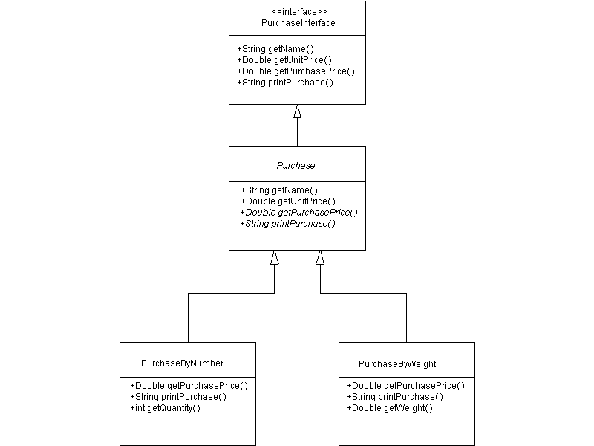
10.
Overall I think the work done here was a success. I managed to make everything work in the way described in the coursework. The use of the abstract class “Purchase” I believe was justified but the use of the interface “PurchaseInterface” was slightly superfluous and I really only used an interface as a technical exercise, the use of the super class alone would have been fine. I can see how in more complex applications however that an interface may have been necessary. I think the GUI could have been better with abit more time, formatting the text area was abit tricky and i'm still not really happy with the result of that.

